Who is to blame for the greenhouse gases???
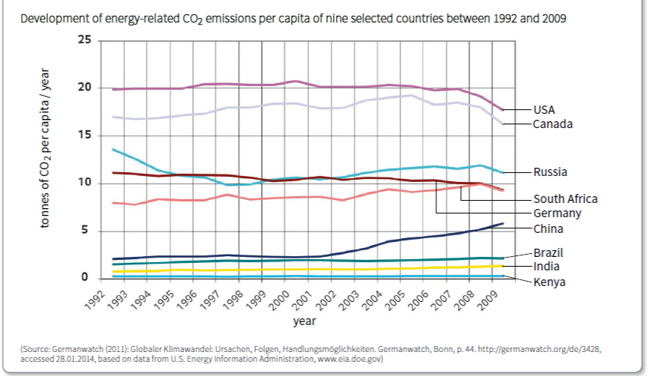
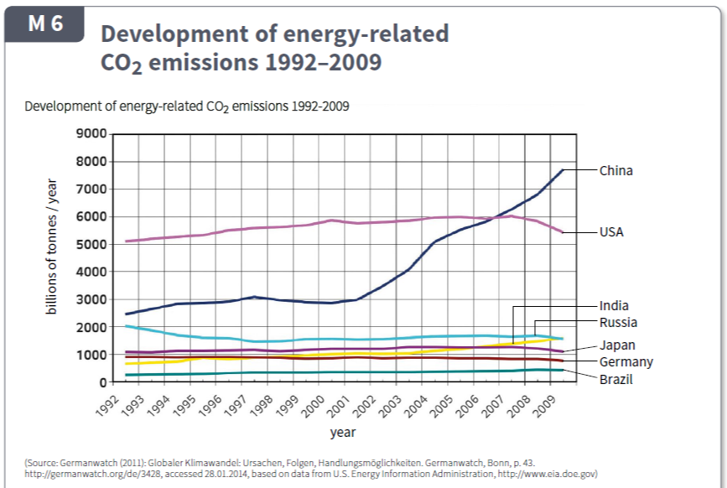
Questions
Look at the two graphs in M6. They both show change in CO₂ emissions, but one shows the change as a total, the other as per person (or capita).
- List those countries whose total CO₂ emissions are increasing
_________________________________________________________________
- List those countries whose total CO₂ emissions are decreasing
_________________________________________________________________
- List those countries whose CO₂ emissions per person are increasing
_________________________________________________________________
- List those countries whose CO₂ emissions per person are decreasing
_________________________________________________________________
- Which of the two graphs in M6 (total CO₂ versus per person CO₂) is the more useful to use when understanding CO₂ emissions. Explain your reasoning.
____________________________________________________________________________________________________________________________________________________________________________________________________________________________________________________________________
__________________________________________________________________________________________________________________________________

Questions
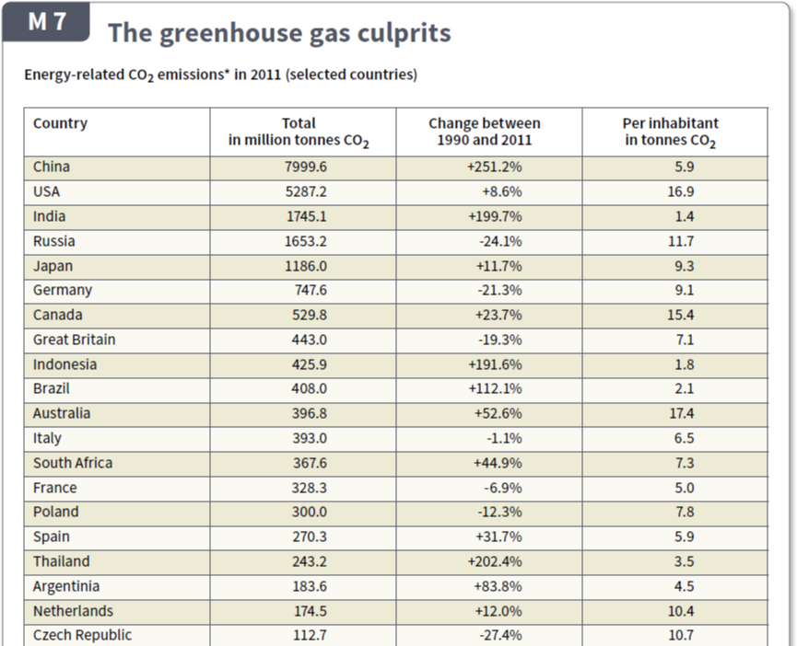
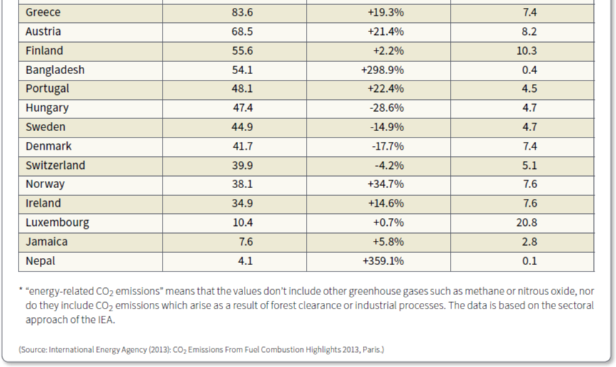
Look at the data in M7. Columns 2, 3, and 4 all show CO₂ emissions for each country but each column presents the information differently.
- Use the information in columns 3 and 4 to complete two bar graphs below.

The second graph should be of the CO₂ emissions per inhabitant - but include only countries which have emissions greater than 10 tonnes
The first graph should be of the percentage increase in CO₂ emissions (column 3), but include only countries which have increased more than 100%

- Which countries are in both bar graphs?
______________________________________________________________
- This is not a coincidence – countries which have recently increased their CO₂ emissions a lot, are generalyy not yet major CO₂ emitters per person (inhabitant). Explain why
______________________________________________________________
______________________________________________________________
______________________________________________________________ ______________________________________________________________

